VHDL and ModelSim Helpful Hints

1. Whenever running a simulation make sure to turn off optimization (no checkmark in the box).

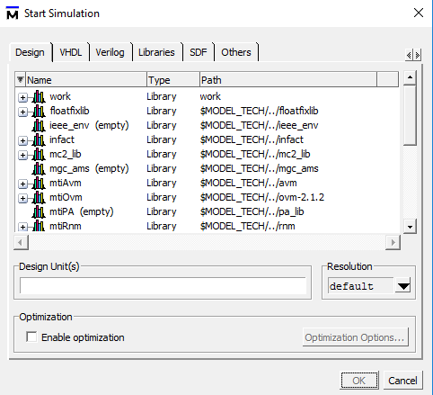

You can check your simulation by looking in the transcript for phrases like ‘design is being optimized’ or ‘loading optimized design’. You should see a warning say the -novopt switch is in effect the design is not optimized.

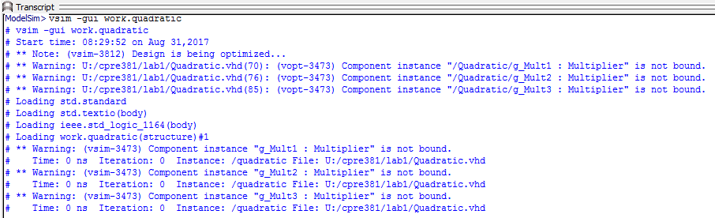

1. Change waves from hexadecimal to decimal by right clicking the wave and then going to Radix->Decimal. This will only change the wave it is displayed but forcing will still be in hex. You can also change the global value using the ‘Global Signal Radix…’ above Decimal in the screenshot below.

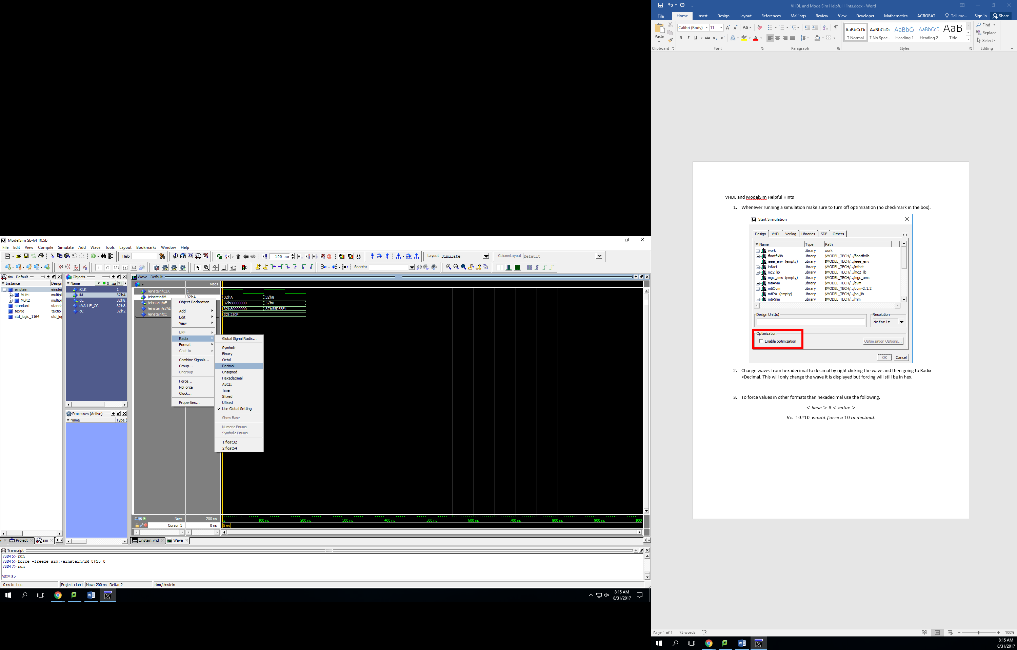

1. To force values in other formats than hexadecimal use the following.
$$<base>\#<value>$$

$$Ex. 10\#10 would force a 10 in decimal.$$

2. Save a file before compiling it. Check this by looking at the bar with the file name on it. If there is a star it has not been saved.

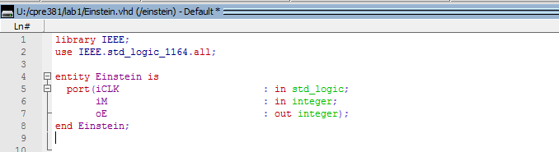

1. When simulating a file make sure all components that it uses are compiled. For example, the quadratic file from the first lab used both the Adder and the Multiplier.

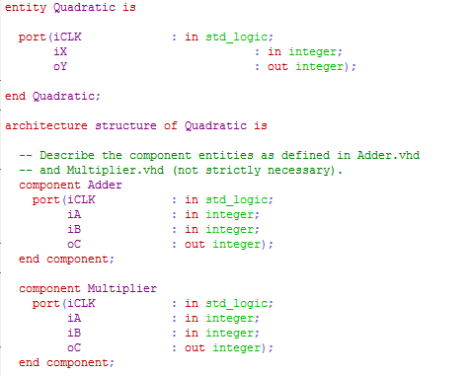

When using a project if the shape next to a file is not a green check, then the file has not yet been compiled.

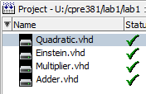

Other ways to check include looking in the work folder with Simulate->Start Simulation to check which files have been compiled. Or looking in the transcript window for ‘<name>’ not bound post starting a simulation.

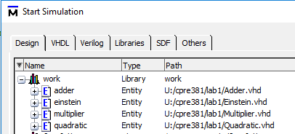



1. Make sure that your VHDL entity name matches with your file name, this will make it easier when debugging. When compiled, the name that you will see in the work folder will be the same as the entity name. So if you have two files that perform different features both used by the same project whichever is compiled the last will be the one that is used. For example if I were to forget to the change the entity name of my Einstein file (from lab 1) after copying and pasting when compiling Einstein would not show up, it would also be listed with the name as Quadratic.

